Acceptance Test Cases

abcxyz Scanner

# Test Case 1 – Capture Packets

Packets displayed in the Scanner will match the raw console output for the current capture.

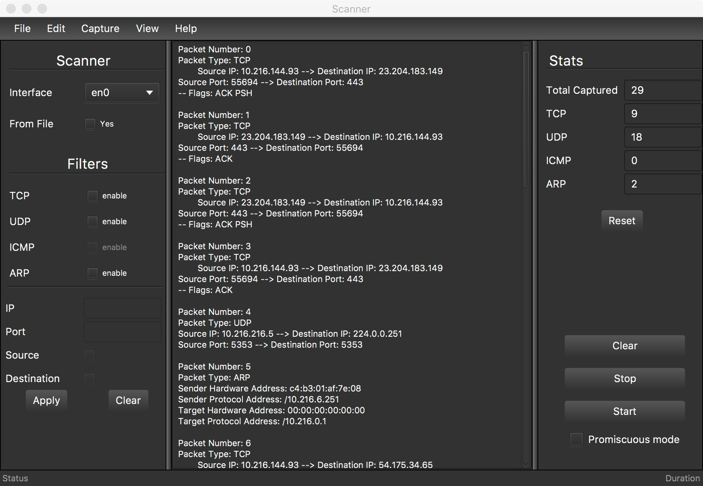

Scanner capture output without filters applied

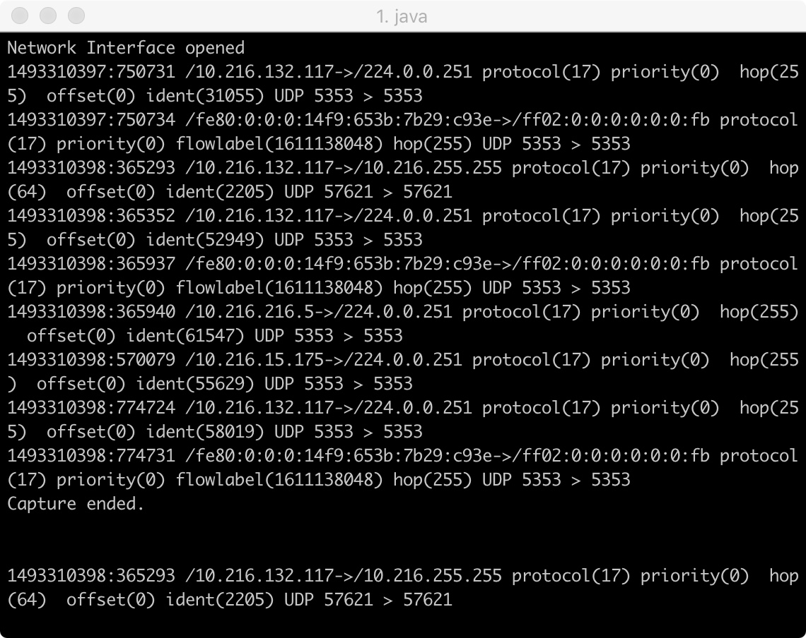

Raw capture output seen in the console

# Test Case 2 – Filter Packets by Protocol

Only the packets from the protocol specified by the user will be displayed

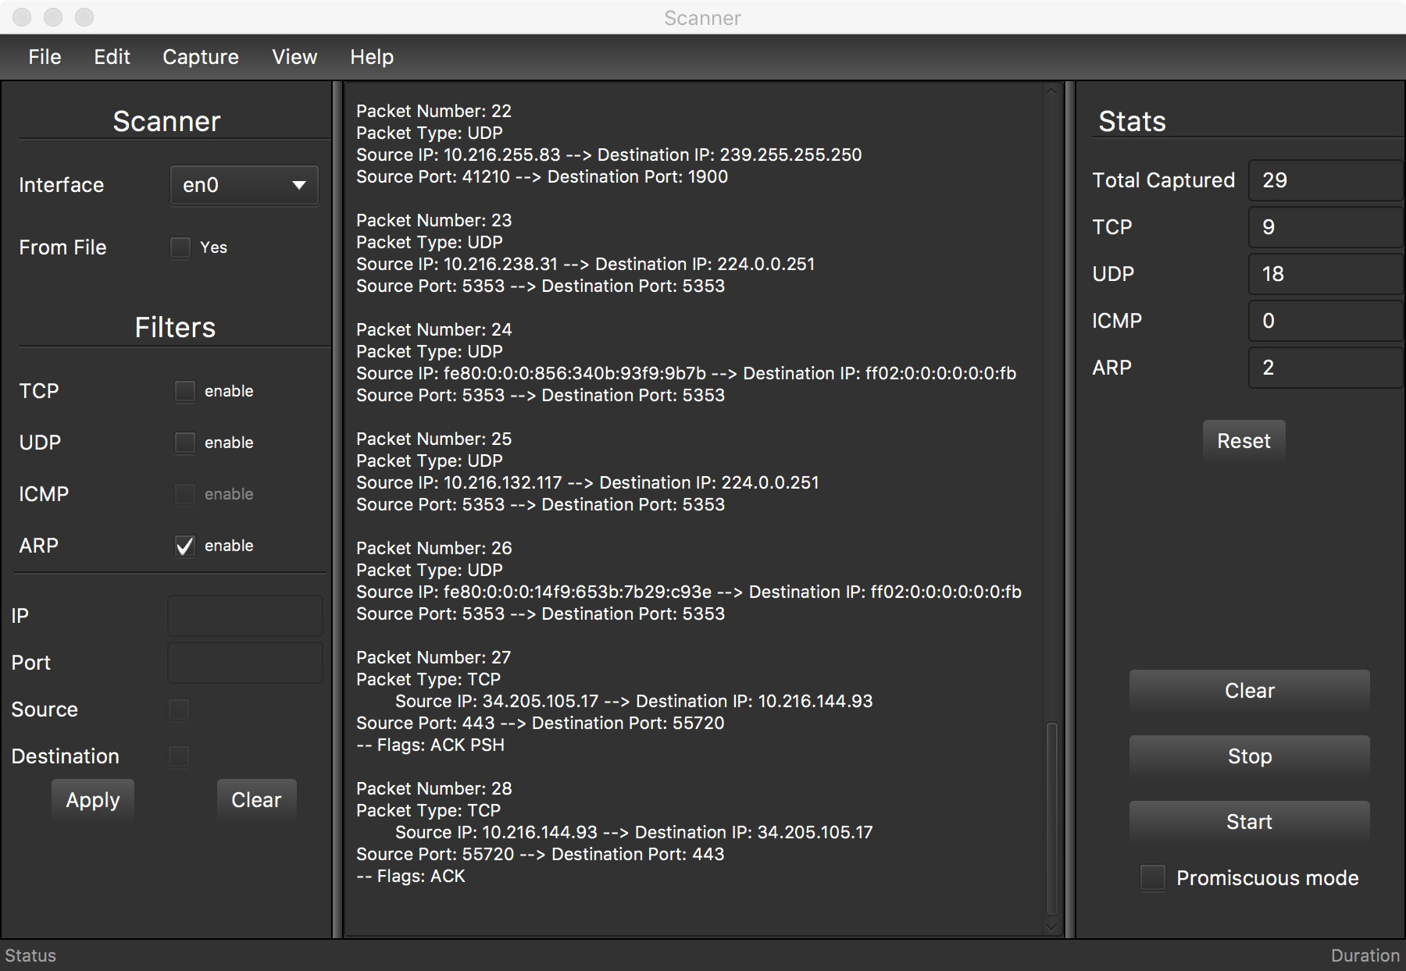

Protocol is selected by the user

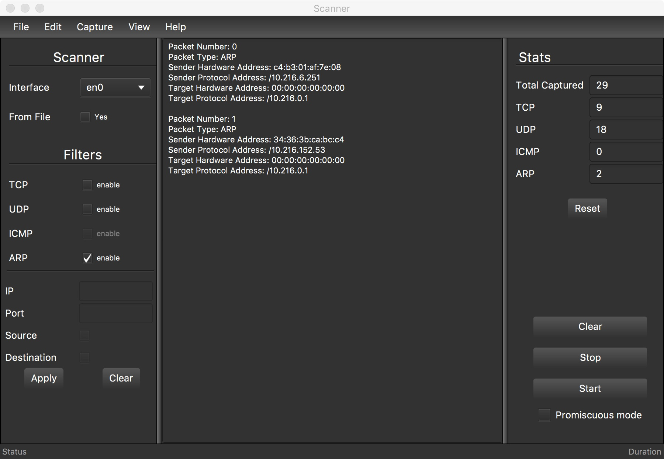

The result will only display the selected protocol

# Test Case 3 – Filter Packet by IP

The Scanner IP filter test was completed by visiting google.com and checking if the header information matched the filtered information in the Scanner.

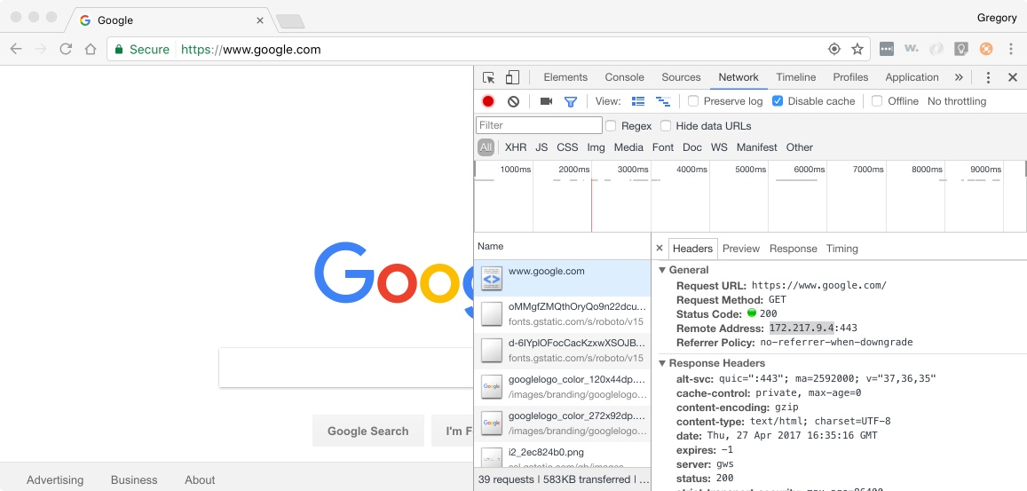

Google.com inspect interface displaying the GET header

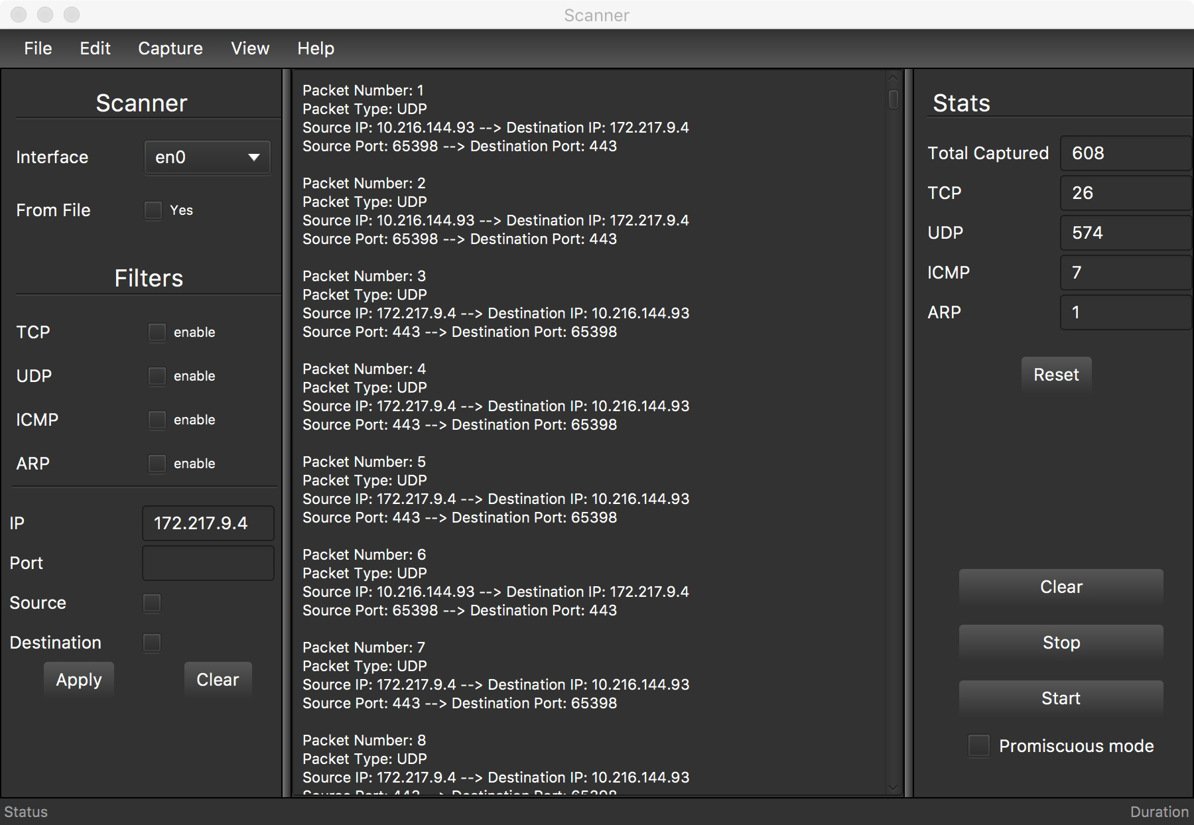

Matching IP source and destinations from the Google.com

# Test Case 4 – View Network Interfaces

View network interfaces in program and compare them to the current machine via ipconfig or ifconfig

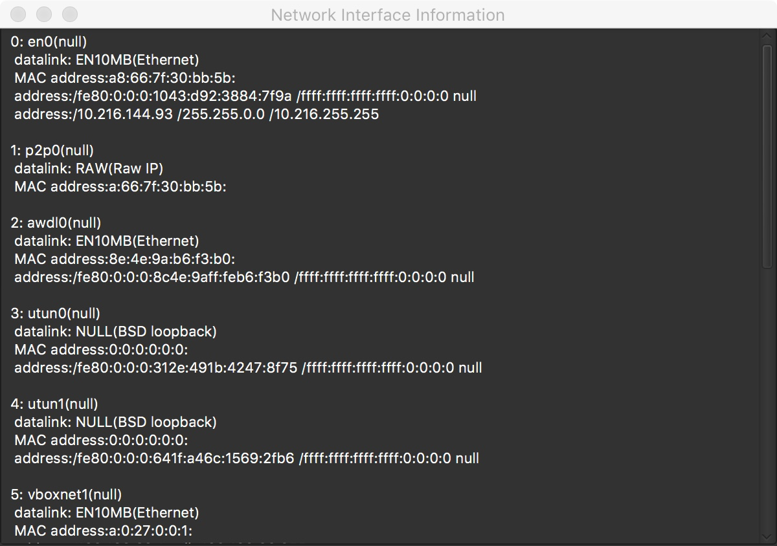

Network interfaces seen in the Scanner program

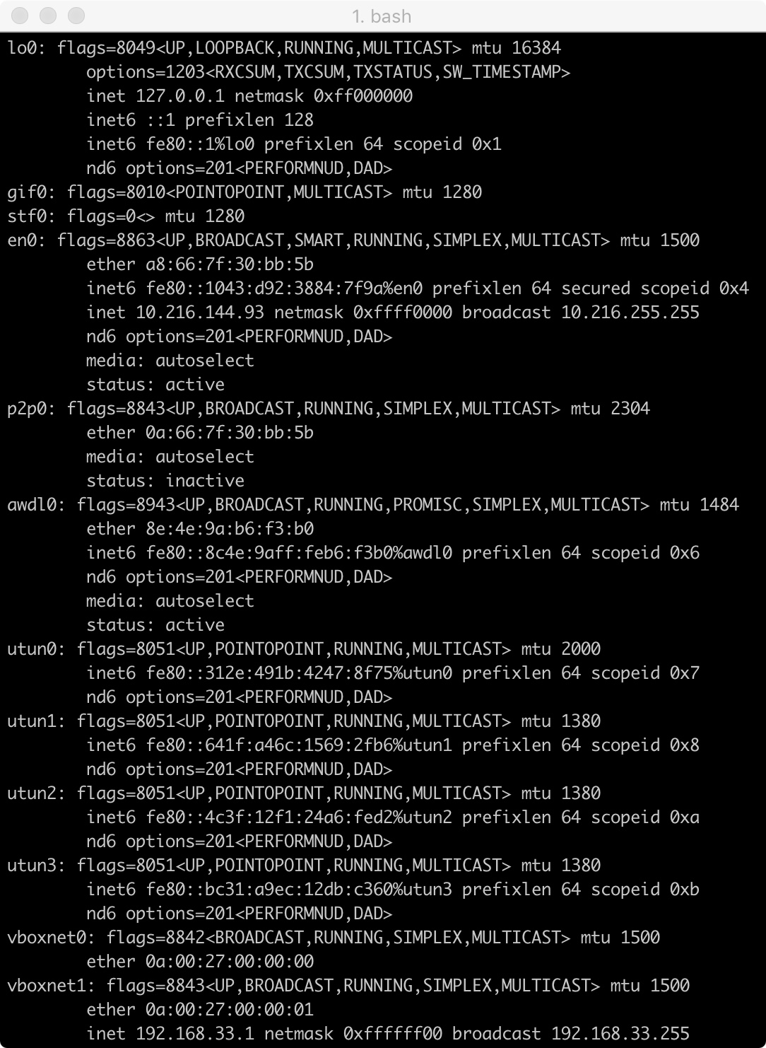

Network interfaces seen in the console via ifconfig

# Test Case 5 – Filter by Port

The Scanner Port filter test was completed by visiting google.com and checking if the header information matched the filtered information in the Scanner.

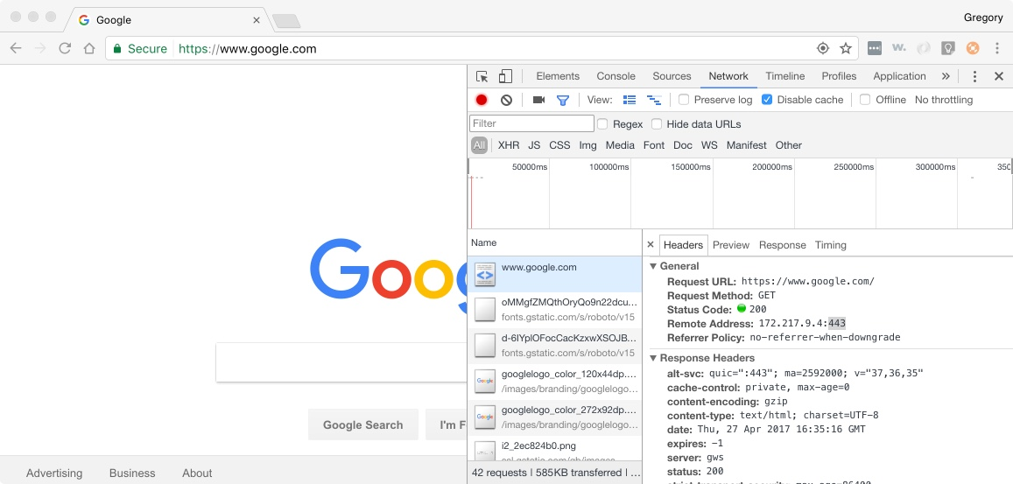

Google.com inspect interface displaying the GET header

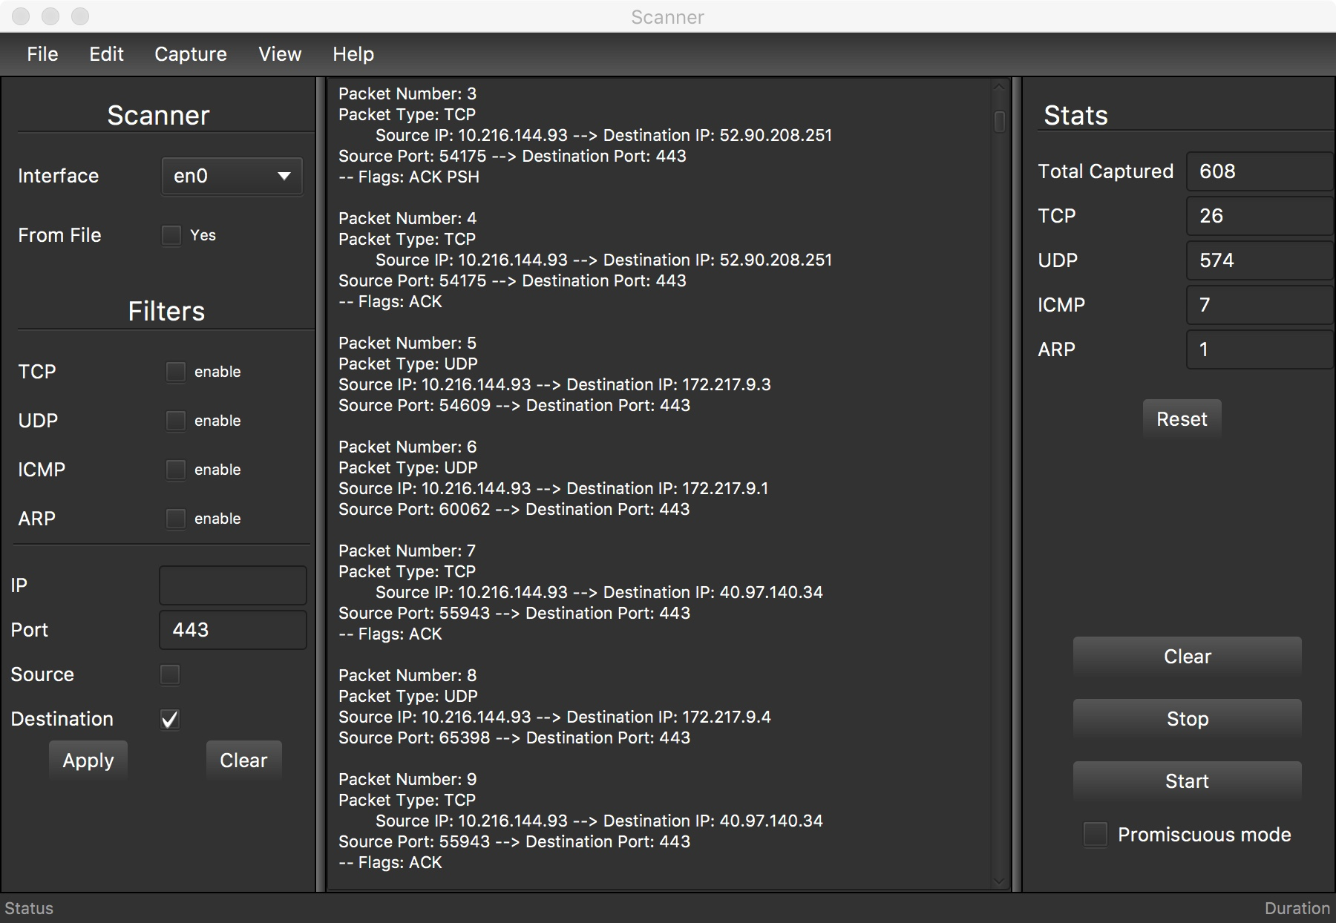

Matching Port destination from the google.com